15.Writing Wireshark Filter Expressions for Packet Capture

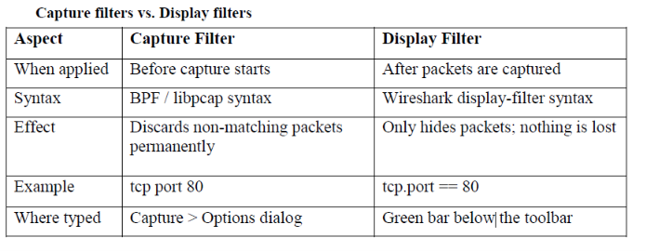

Worked Examples of Filter Expressions
(a) Capture filters (typed in Capture > Options)
host 192.168.1.10 # all traffic to/from this host
net 192.168.1.0/24 # entire subnet
src host 192.168.1.10 # only packets FROM this host
dst port 53 # traffic going TO port 53 (DNS)
tcp port 443 # only HTTPS/TLS traffic
udp # only UDP packets
not arp and not broadcast # ignore ARP and broadcasts
tcp port 80 and host 192.168.1.10 # combined condition
(b) Display filters (typed in the green filter bar)
ip.addr == 192.168.1.10 # any packet with this IP (src or dst)
ip.src == 192.168.1.10 # only where this IP is the source
tcp.port == 80 # HTTP over TCP
http # only HTTP protocol packets
dns # only DNS packets
http.request.method == "GET" # only HTTP GET requests
tcp.flags.syn == 1 && tcp.flags.ack == 0 # TCP connection starts (SYN)
tcp.analysis.retransmission # retransmitted TCP segments
ip.addr == 192.168.1.10 && tcp.port == 443 # host AND port together
frame contains "password" # packets whose bytes contain the text

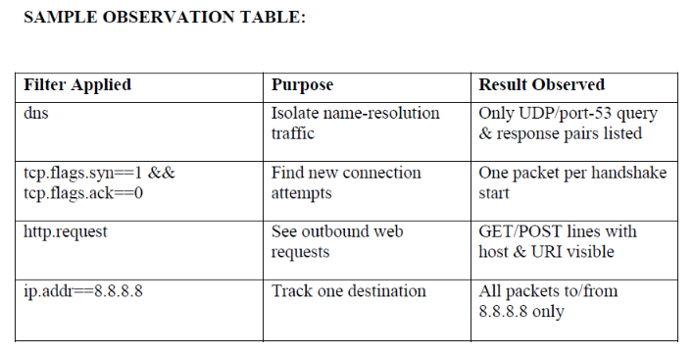

16.Analysis of RTP Packet Delay and Loss using Wireshark
Useful Display Filters
rtp # show only RTP media packets
rtcp # show only RTP control/report packets
rtp.ssrc == 0x12345678 # a single media stream by its SSRC id
rtp.marker == 1 # talk-spurt / frame boundary markers
sip # the SIP signalling that set up the call
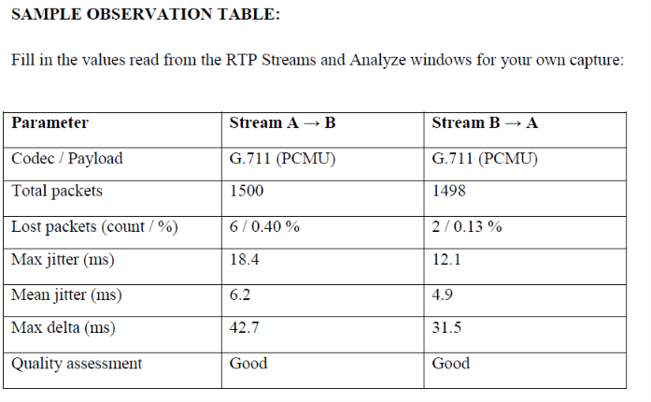

17.Use Wireshark to Inspect Packets on Your Network

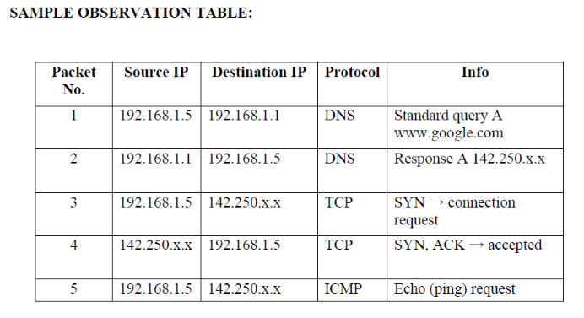
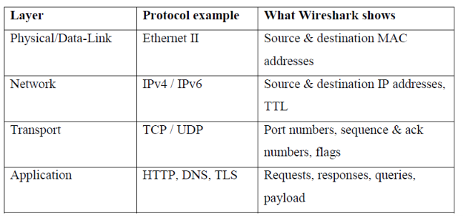
18.Create a Simple Network using Cisco Packet Tracer

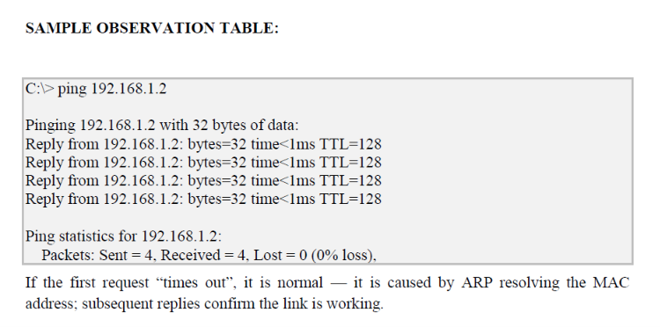
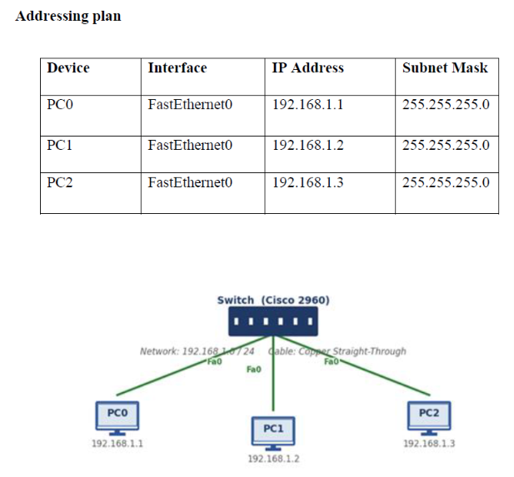

19.Study of Topology - Benchmark LAN Trainer Kit

